MODULE-5
QUESTION AND ANSWER 1:
https://leetcode.com/problems/power-of-two/description/
bool isPowerOfTwo(int n) {
return n > 0 && (n & (n - 1)) == 0;
}
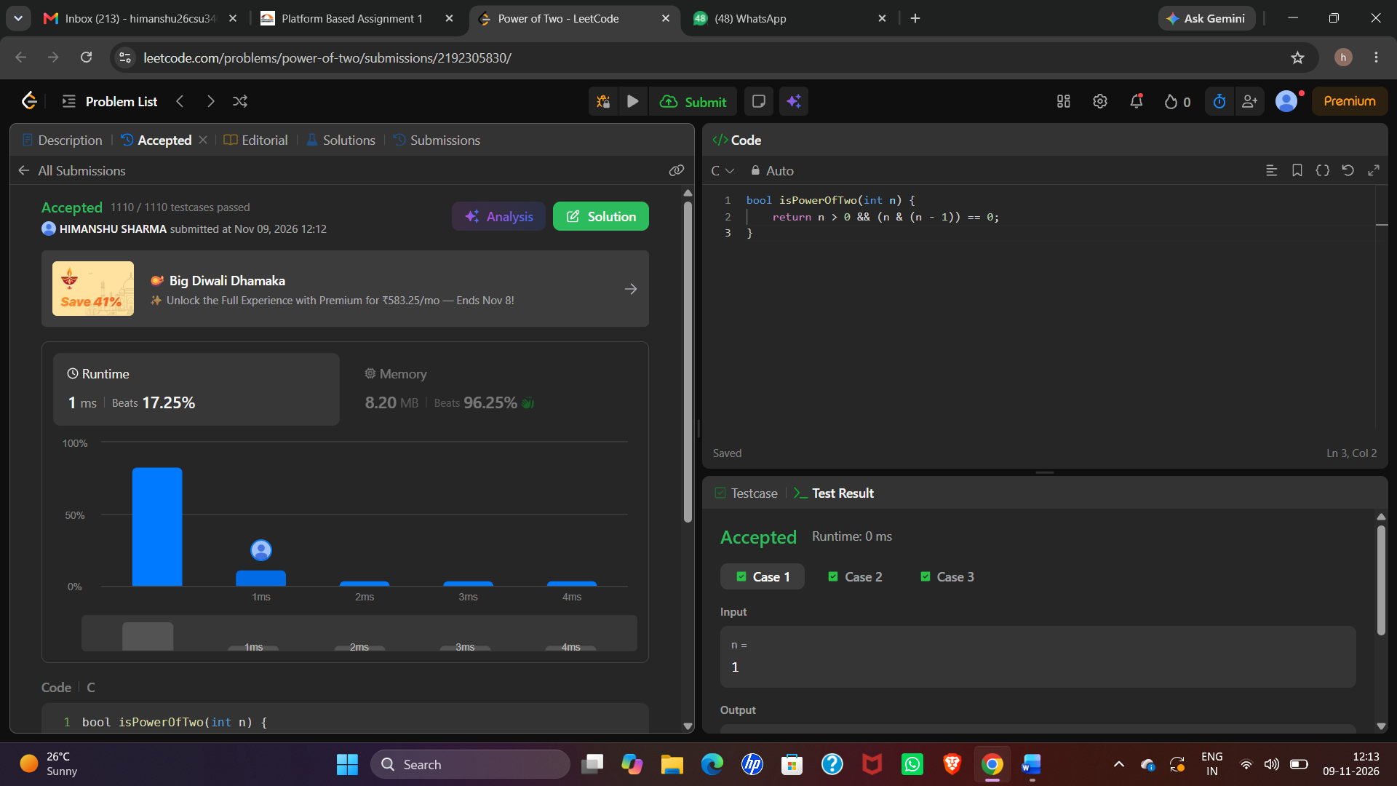

MODULE-5
QUESTION AND ANSWER 2:
https://leetcode.com/problems/power-of-three/
bool isPowerOfThree(int n) {
if (n <= 0)
return false;
while (n % 3 == 0) {
n = n / 3;
}
return n == 1;
}
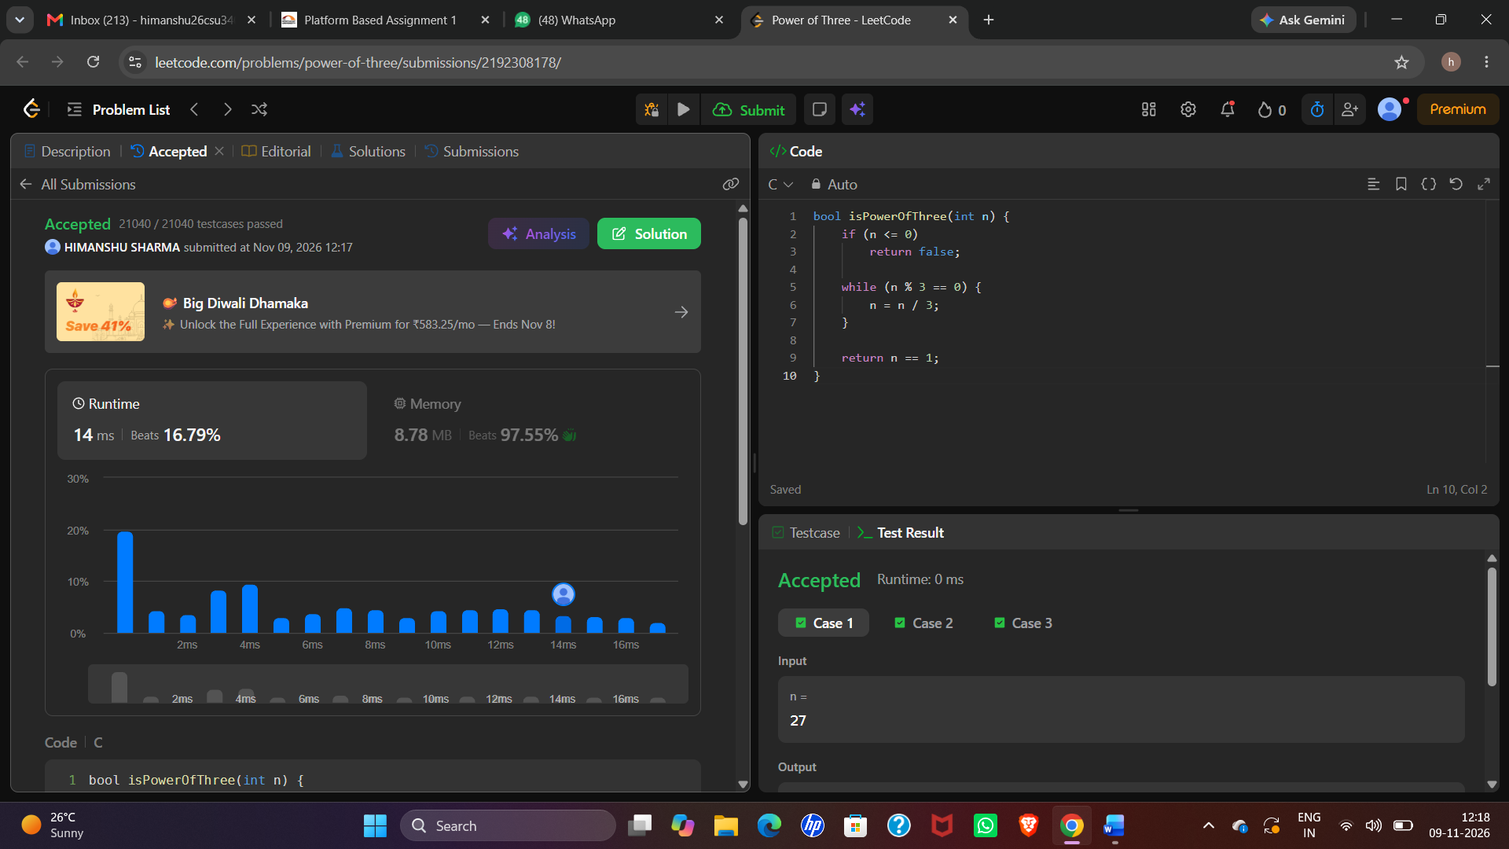

MODULE-5
QUESTION AND ANSWER 3:
https://www.hackerearth.com/practice/basic-programming/input-output/basics-of-input-output/practice-problems/algorithm/find-factorial/
#include <stdio.h>

int main() {
int n, i;
long long fact = 1;

scanf("%d", &n);

for (i = 1; i <= n; i++) {
fact = fact * i;
}

printf("%lld", fact);

return 0;
}
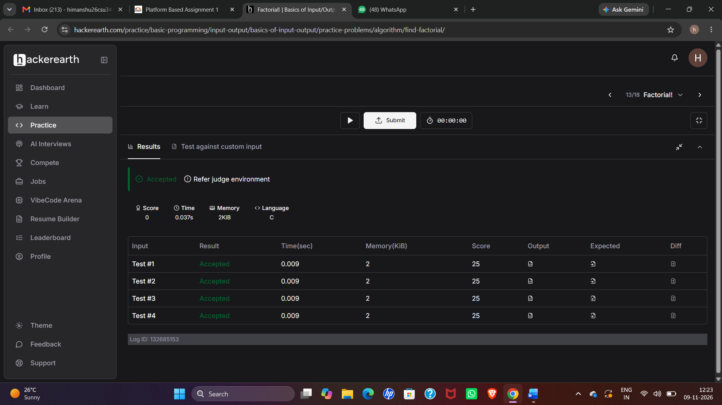
MODULE-5
QUESTION AND ANSWER 4:
https://www.hackerearth.com/practice/basic-programming/input-output/basics-of-input-output/practice-problems/algorithm/count-divisors/
#include <stdio.h>

int main() {
int l, r, k, i, count = 0;

scanf("%d %d %d", &l, &r, &k);

for (i = l; i <= r; i++) {
if (i % k == 0) {
count++;
}
}

printf("%d", count);

return 0;
}
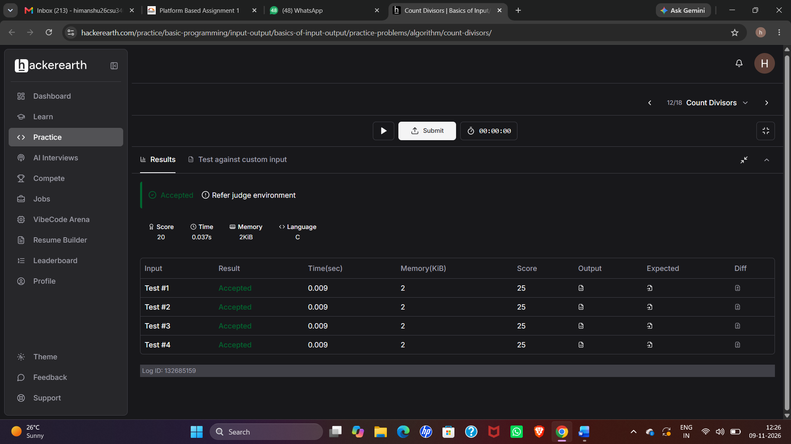
MODULE-5
QUESTION AND ANSWER 5:
https://www.hackerearth.com/problem/algorithm/prime-numbers/
#include <stdio.h>

int main() {
int n, i, count = 0;
scanf("%d", &n);
for (i = 1; i <= n; i++) {
if (n % i == 0) {
count++;
}
}
if (count == 2)
printf("1\n");
else
printf("0\n");
return 0;
}
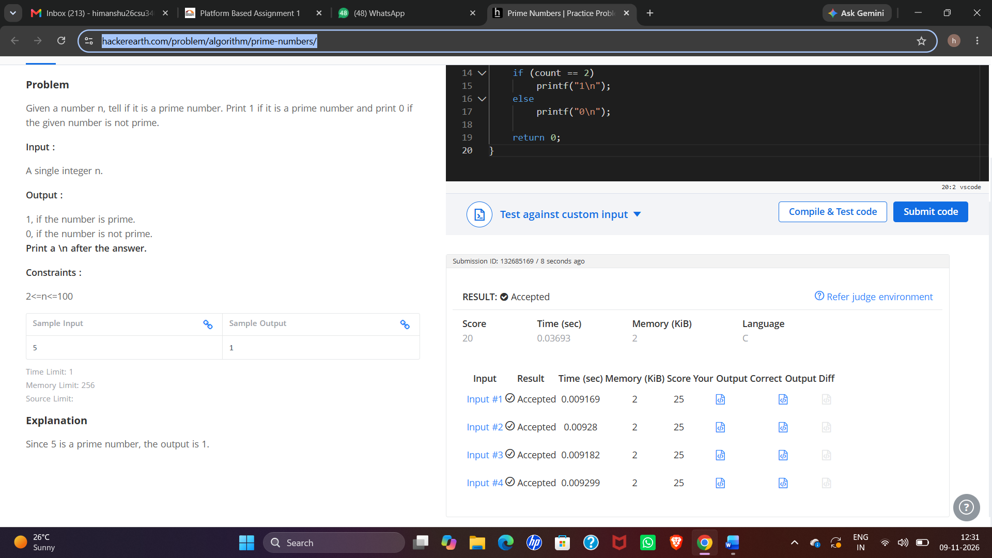
MODULE-5
QUESTION AND ANSWER 6:
https://leetcode.com/problems/perfect-number/description/
bool checkPerfectNumber(int num) {
if (num <= 1)
return false;
int sum = 1;
for (int i = 2; i <= num / i; i++) {
if (num % i == 0) {
sum += i;
if (i != num / i)
sum += num / i;
}
}
return sum == num;
}


